Xerte Online Toolkits v3.0 Release Notes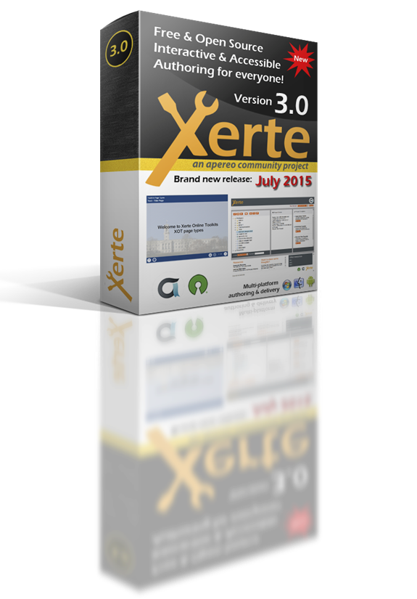

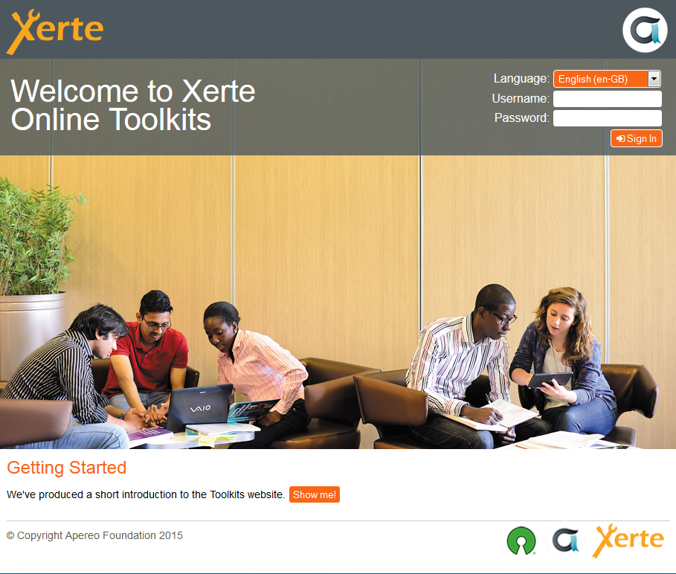

*The new login page for Xerte Online Toolkits v3.0*

The Xerte Project has made huge progress since we last released a new version of the software. We are now an Apereo Community project, and an affiliate member of the Open Source Initiative, both of which firmly establish us as a successful and sustainable project, and provide fantastic opportunities to expand our community of users and developers.

This document explains some of the moves the project has made and introduces the new features and functionality in Xerte Online Toolkits v3.0. Version 3.0 represents a big step forward for the software.

The Apereo Foundation  
Xerte Online Toolkits v3.0 is the first release of the software as an Apereo Foundation project. As the project has grown, and the community of developers and users has expanded, The University of Nottingham has transitioned stewardship of the project to The Apereo Foundation. Much of the development in recent years has been from contributions from the fantastic team of Xerte Community developers external to the University of Nottingham, and this wider project team worked through the Apereo incubation process over the winter and spring of 2015 / 16 graduating in May, with a beta release of v3.0.

Ian Dolphin, Apereo Foundation Executive Director said "This is great news for the Xerte Community and Apereo.  Xerte’s strengths – particularly around interactivity and accessibility – complement other Apereo offerings. The Foundation looks forward to bringing Xerte to a broader constituency"

Julian Tenney, The Xerte Project’s Lead Developer said “This is exciting news; it’s the next logical step for the project to take. In particular, we’re looking forward to the new opportunities this will create, and it will be great to be part of the wider Apereo community.”

Since then, we’ve found a fixed a few more issues thanks to the beta testing, and we are now very excited to bring you Xerte Online Toolkits v3.0, which we think is the best release we’ve ever made, with some really exciting new features and functionality.

You can find out more about Apereo at the Apereo website: <https://www.apereo.org/>

Open Source Initiative  
The Xerte Project has also been accepted as an affiliate member of the Open Source Initiative.

The OSI's General Manager, Patrick Masson said, "The Xerte Project exemplifies exactly what the OSI hopes to foster across the higher education and open source communities. The project and community have collaborated with several organizations to grow and mature, including with another OSI Affiliate, The Apereo Foundation. It is exactly these relationships and benefits between communities that the OSI is working to create and promote."

Julian Tenney added, “The OSI establishes very high standards for affiliate projects, and we’re really proud to be accepted as an OSI affiliate member.”

You can find out more about the OSI at the OSI website: <http://opensource.org/>



*From The Xerte Project’s Github wiki, where you can find more information about the project, how it works and how to get involved.*

License Change  
The software is now licensed under the Apache License v2.0 which removes a number of barriers to adoption associated with the GPL. In particular, the Apache license makes it clear that you can use the software for whatever you want, with no strings attached and provides assurance that the software can be deployed without any obligations in any setting. We have thoroughly reviewed the code for this release to ensure it complies with the Apache license.

Governance  
The Xerte Project is a meritocratic, consensus-based community project. Anyone with an interest in the project can join the community, contribute to the project design and participate in the decision making process. This wiki describes how that participation takes place and how to set about earning merit within the project community. We are a very friendly community and always ready to welcome new contributors. You can find out more about how the project works, and how to get involved at our github wiki: <https://github.com/thexerteproject/xerteonlinetoolkits/wiki>

Xerte Online Toolkits v3.0 New Features and Enhancements

We have fixed over 250 issues and introduced a wide range of new features and enhancements in the Xerte Online Toolkits v3.0.

Server Requirements

* Apache or IIS or others
* PHP 4.3 or later (the extensions needed are PDO, zLib, SimpleXML and LDAP (if you are using for LDAP authentication)
* MySQL

For additional installation instructions, see the install guide included in the /documentation folder. For support during installation use either the xerte mailing list, or the forums at our community website: <http://www.xerte.org.uk>.

Registration  
You will be invited to register your installation of Xerte Online Toolkits during setup. We strongly encourage you to do so. We will only use the information to inform you of any critical updates or patches necessary to keep your install running or to let you know about new releases and updates.

Workspace  
The workspace has been overhauled to make it easier to use and although we’ve made some changes, it will be familiar to existing users. We’ve redesigned the layout to allow the workspace to function on mobile devices, and we’ve given greater prominence to some of the key project information otherwise found in the properties panel. You can now search your workspace for projects using the search facility, and we’ve completely replaced the projects tree with a much better solution: dragging and dropping projects now works much better, for example, and you can now double click a project to edit it.

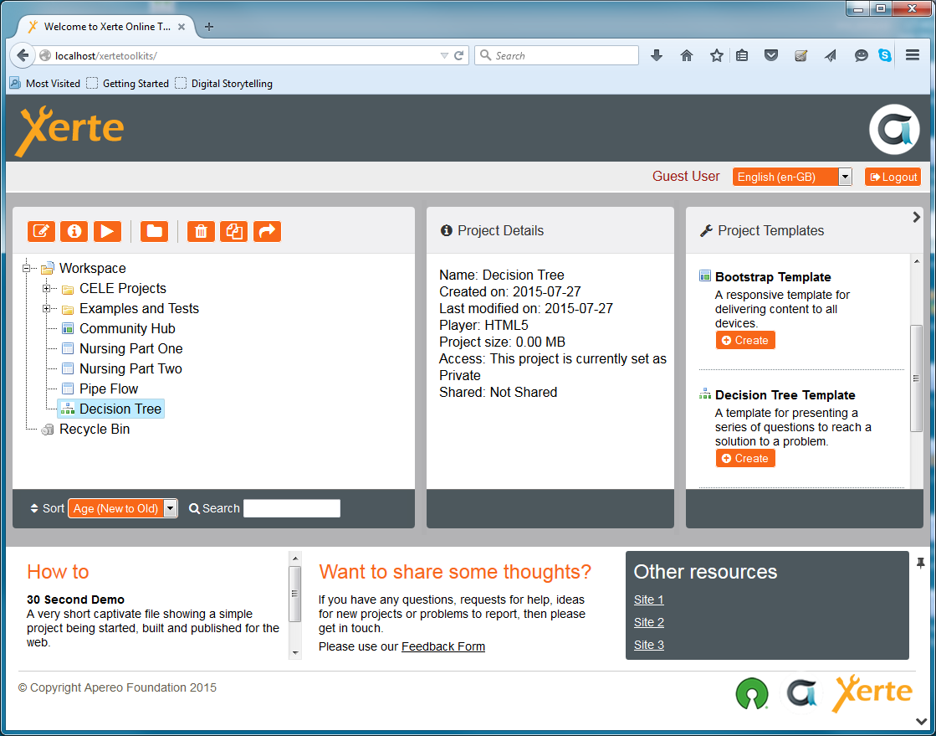

All New HTML Editor  
This is the most significant change in Xerte Online Toolkits v3.0, but using it will be familiar to existing users as the workflow is unchanged from the previous version, and visually there are many similarities. There are some powerful new features, particularly WYSIWYG editing and the media library.

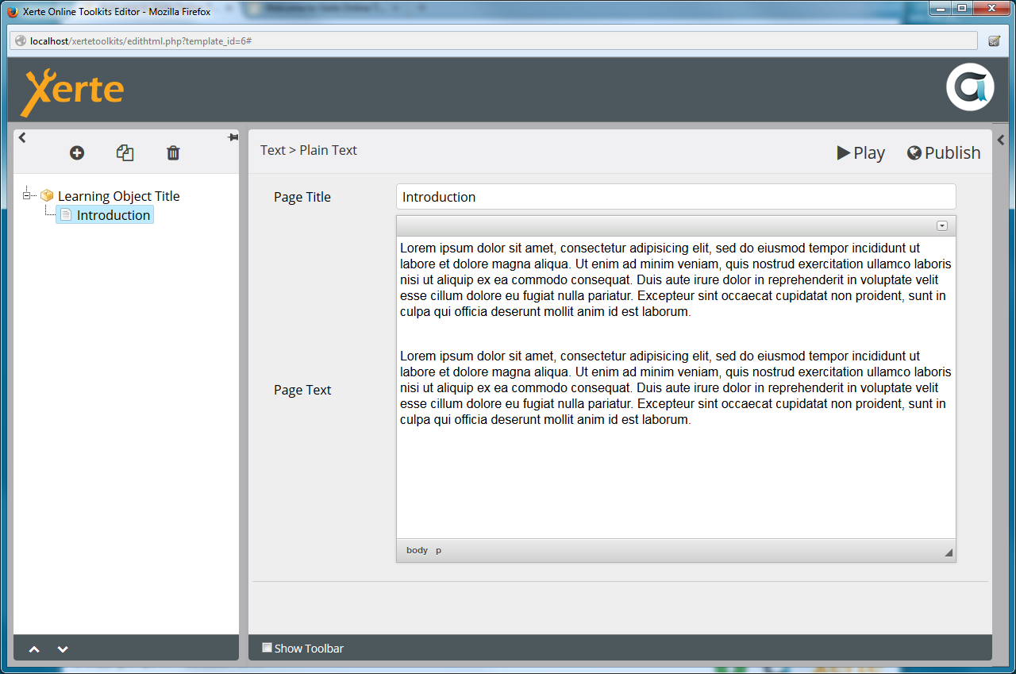

*The all-new HTML-based editor is a huge step forward from the old flash-based tools.*

Over the last few years we have been working to remove all dependencies on the Flash Player. The first phase of that work was complete with Xerte Online Toolkits v2.0 when we released the HTML5 runtime which allowed content to run on devices that didn’t support Flash. The second phase of the work is now complete with the transition of the old Flash-based editor to an all-new HTML-based editor. The new editor introduces a number of powerful features and addresses some common ‘wish list’ items from our users, and it is now possible to use Xerte Online Toolkits on a much wider variety of devices for authoring.

Existing users with projects using the older Flash-based runtime should now consider upgrading those projects to the HTML5 runtime as we will no longer be supporting or updating the Flash-based delivery of content, and some browsers are now blocking flash-based content. This is a simple step: just check the HTML5 checkbox in the project properties. Since there are some visual differences between the two delivery systems, you should check your project looks OK in the HTML5 interface – although the vast majority of projects will transition seamlessly. There will be no loss of functionality when you upgrade your projects.

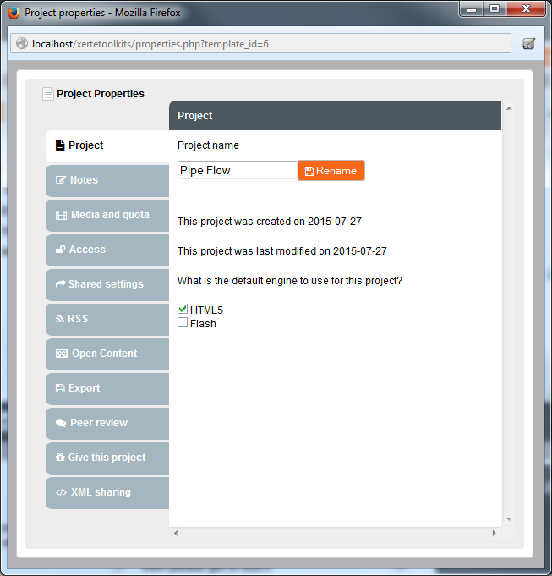

*It’s easy to migrate older projects to use the new HTML5 based runtime, and all users are now encouraged to do so as we will find it increasingly difficult to support the flash runtime as we introduce new features and functionality.*

WYSIWYG Editing  
One of the most requested features from our users has been for WYSIWYG editing: the new editor makes this possible. A new toolbar contains a range of controls, affording users much more control over the formatting of content and making it much easier to create bullets, hyperlinks, subscripts and superscripts and insert mathematical formula. You can now insert media directly into the page’s text, and HTML coders can work directly with the underlying source. The suite of media presentation templates is still available if you want to author content without worrying about layout, but the WYSIWYG editing offers a lot of flexibility for designers and content authors.

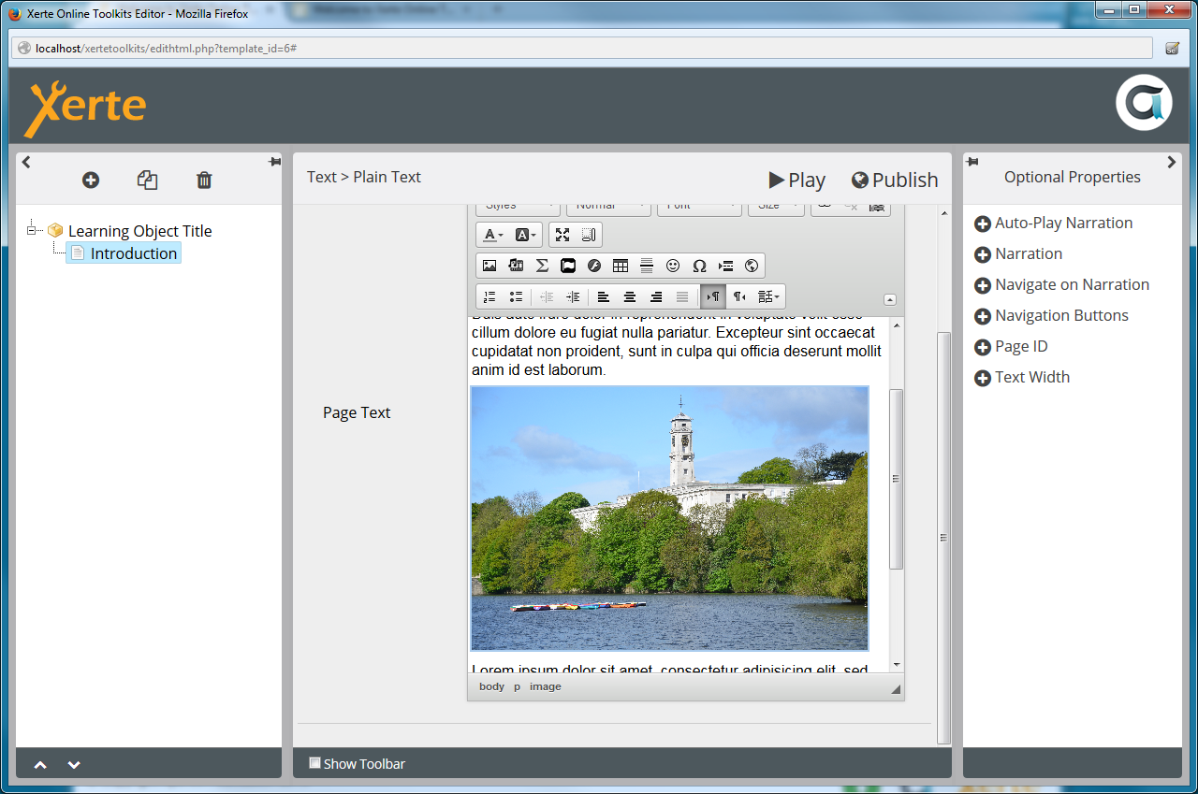

*WYSIWYG editing provides a lot more control over formatting and makes it a lot easier to insert links and other items that would previously have meant writing html directly.*

Enhanced Media Library  
The new editor provides a much better media library. You can now upload more than one piece of media at a time, and you can insert images into any text field directly. The new media library allows you to browse the project’s media and select items for inclusion.

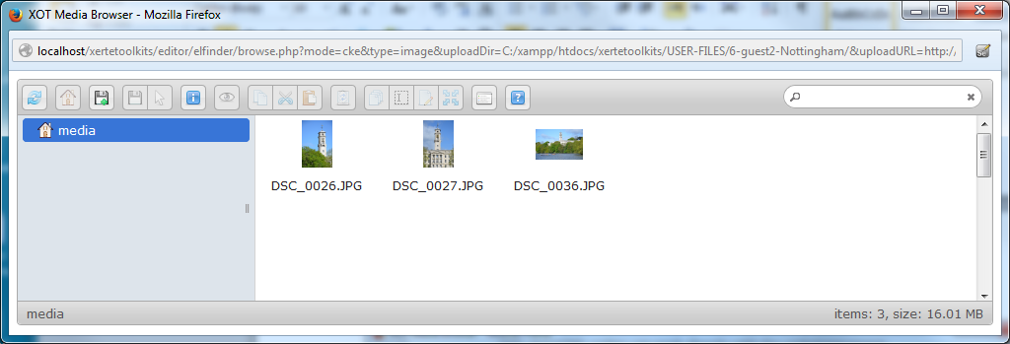

Optional Properties  
The optional properties menu has been redesigned to make it much easier to use: you might need to expand the panel to the right to bring the optional properties panel into view. This panel lists all the optional properties for a page, and you can insert an optional property by clicking on it in the list. To remove an optional property, simply click the ‘trash’ icon next to it in the editor.

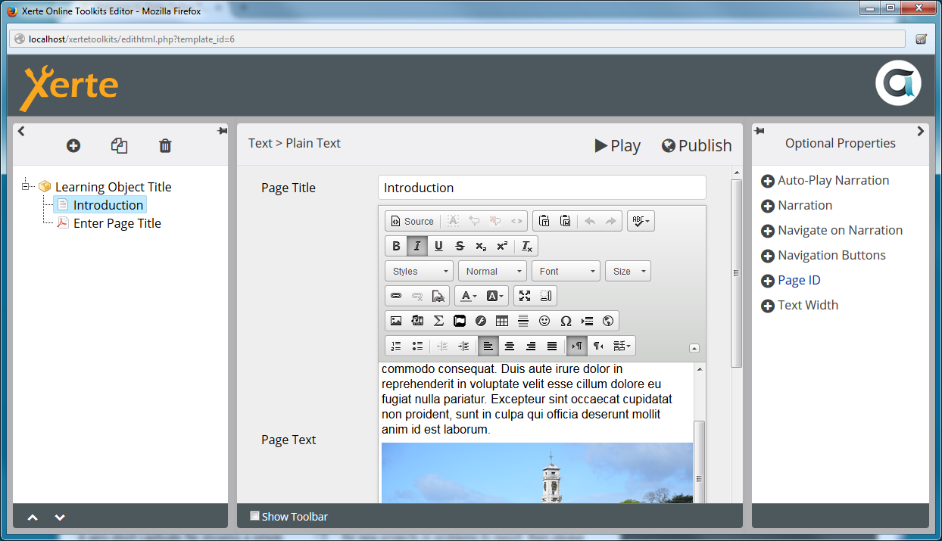

*Showing the new optional properties tab on the right hand side of the editor. You need to expand this panel to access the optional properties.*

Insert Menu  
The Insert Menu has been redesigned but functions in a very similar way to the old one and will be familiar to existing users. When inserting a page you can now choose whether to put the new page at the end of the project or you can choose to place it before or after the currently selected page in the project tree.

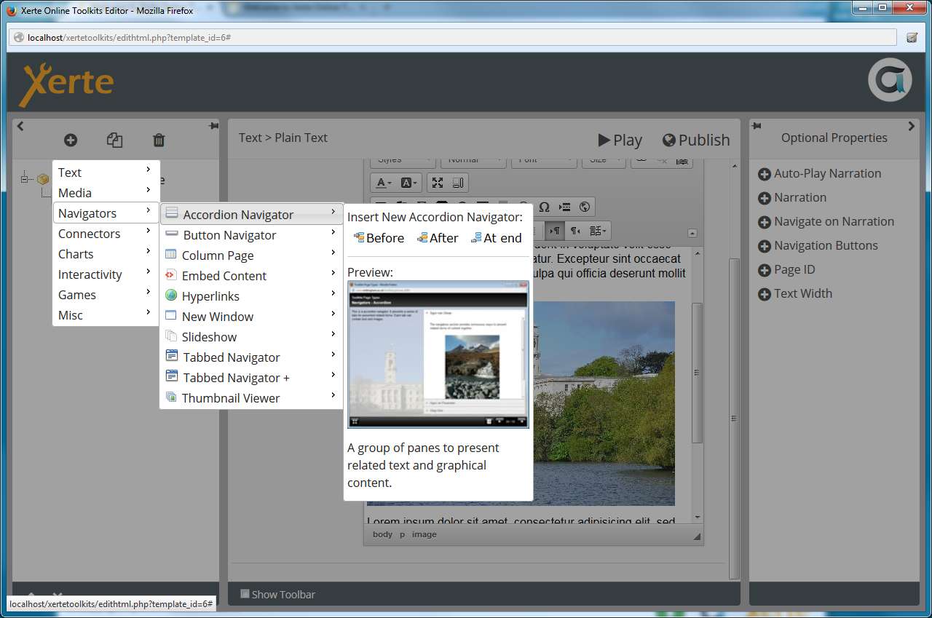

*The new ‘Before’, ‘After’ and ‘At end’ buttons on the insert menu.*

Paste from Word   
The most common reason for problems with data is when pasting in content from Microsoft Office applications, as it often contains unseen formatting which causes problems with the project’s data. Many other CMS systems face the same problem, so it’s not a Xerte specific issue. The new editor contains a button ‘Paste from Word’ which will make this problem much easier to avoid.

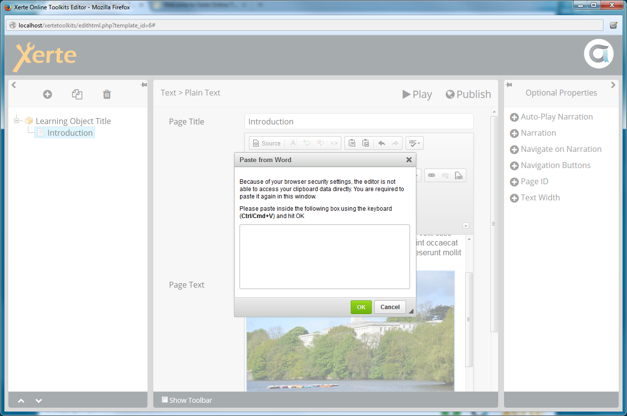

*Showing the ‘paste from word’ dialog, which should help prevent the issues associated with pasting content from MSOffice applications.*

Just in case things do go awry, we have also ensured that automated backups of project data are made which will make it much easier to access data from previous editing sessions should anything go wrong. We should stress, however, that this is extremely rare, but we do take the loss of user data very seriously and this provides an extra level of protection.

Xerte Online Toolkit Template  
A number of new features and enhancements have been made to the Xerte Online Toolkit Template. We have overhauled the number of templates available and removed some of the templates that were necessary to work around some limitations with the Flash Player: there are now 57 templates included and whilst some templates have been retired, there is more flexibility than ever in the suite. Xerte Online Toolkits provides one of the most comprehensive suite of authoring templates in any authoring tool. As always, if you have ideas for new templates for presenting media or interactivity, the developer team would like to hear about them! One of the great strengths of Xerte Online Toolkits is that it has been built to support real world use-cases and we are always interested in new functionality that users would like to see.

*Themes*You can now choose from a range of themes for your projects, using the ‘theme’ property on the Learning Object icon. We know this will be a very popular feature, allowing developers to add their own themes to the list, and we’d really like to share any themes you develop with the wider user community.

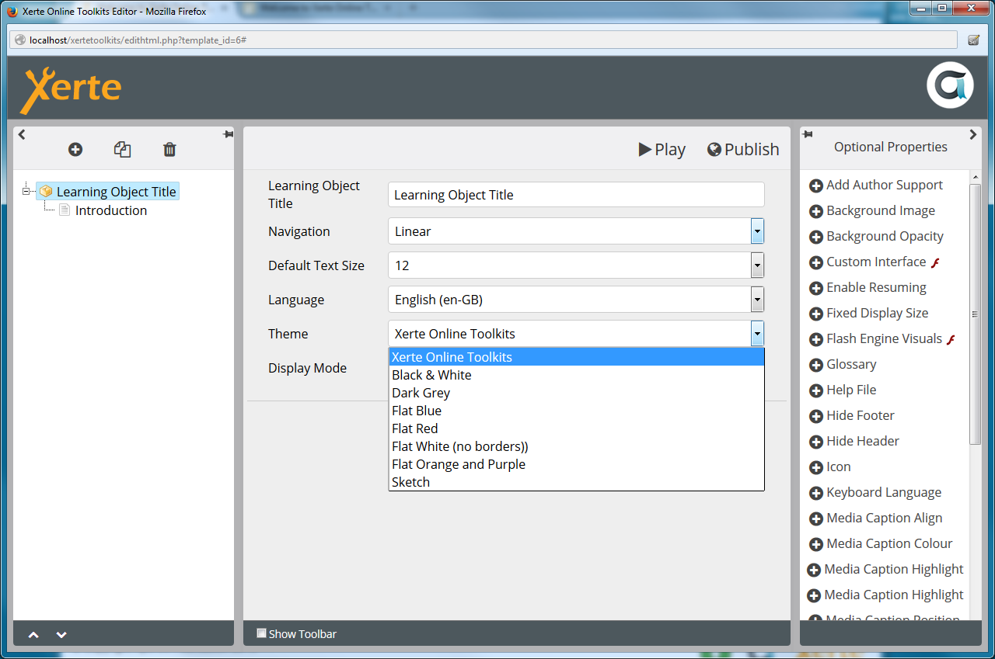

*Showing the themes selector in the Xerte Online Toolkits template.*

*Media Lesson*Media Lesson is a very powerful new template allowing you to synchronise the display of media and interactivity with the playback of either video or audio. This opens up some very interesting possibilities for creating much more interactive media presentations.

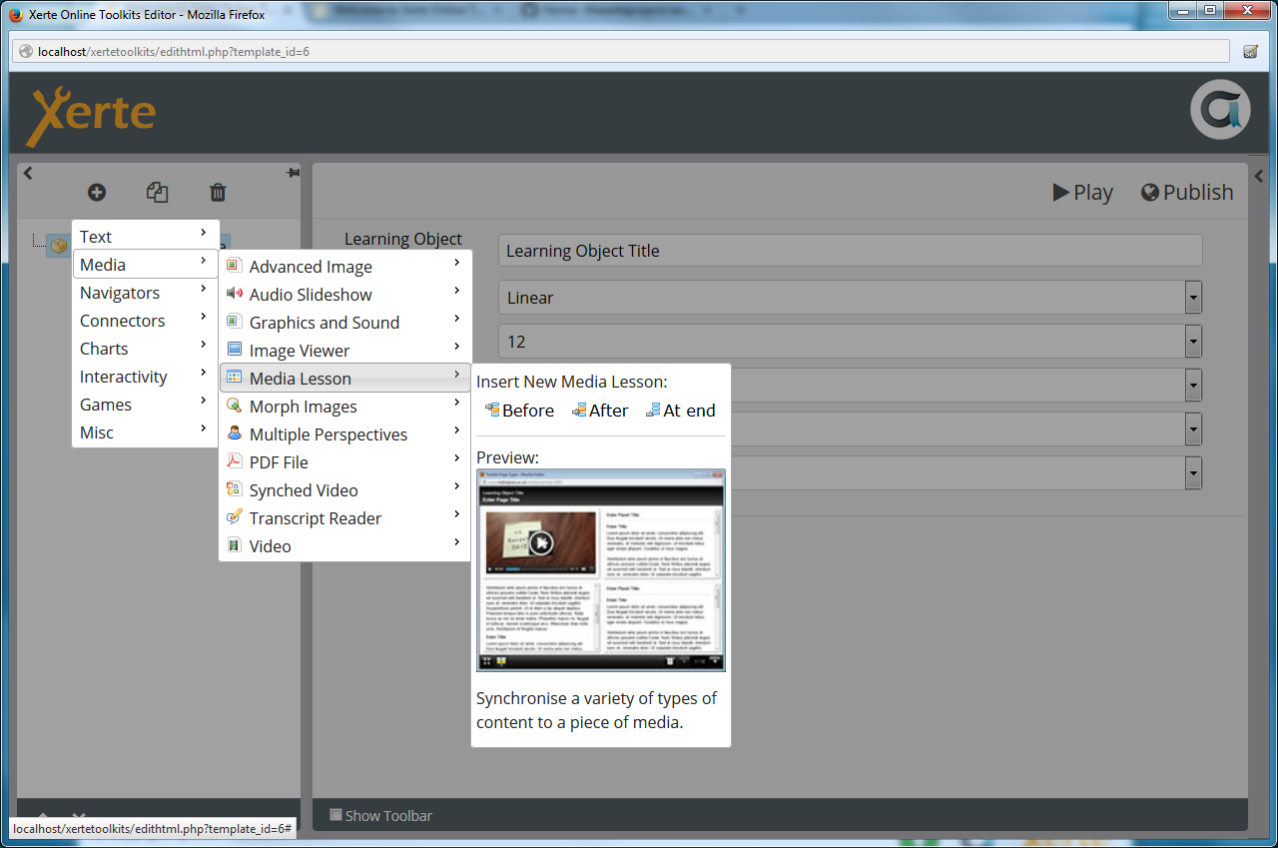

*Inserting a new Media Lesson page from the insert menu.*

*YouTube and Vimeo*You can now use embed code from youtube or Vimeo in any place you could previously upload video. We encourage users to make use of streaming services such as YouTube because the experience for end-users will frequently be better by drawing on these services, which can cope with a variety of network conditions and a wide variety of devices. Of course, you can still work with mp4 files directly.

*New PDF Template*A new PDF page replaces the older Flash paper template. PDF has become the de-facto document format on the web and is now much easier to integrate into your Xerte Online Toolkits projects.

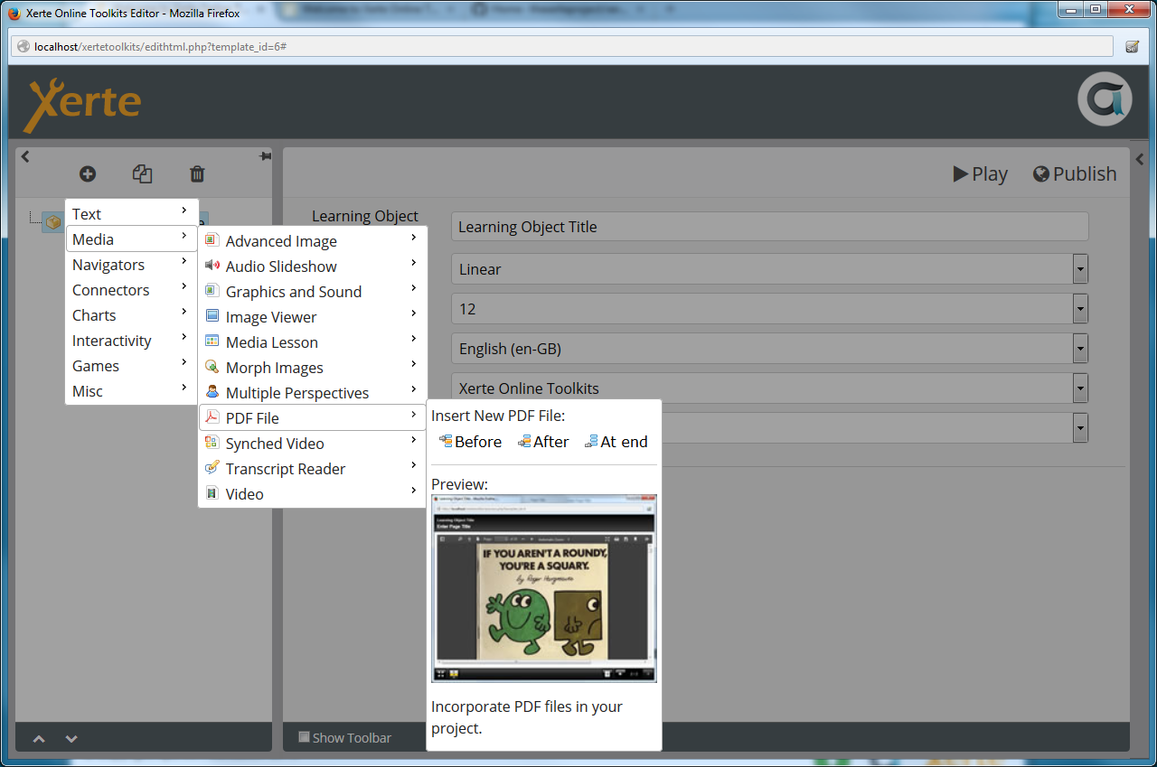

*Inserting the new PDF page. Adding a PDF file works in exactly the same way as any other media.*

*Youtube RSS - API Key Required*YouTube have changed their policy on using their API: system administrators will now need an API key to make use of the YouTube RSS page. To provide the key, place it in the api_keys_dist.php file, and rename the file to api_keys.php. This ensures that any future updates won’t overwrite your settings.

*Basic Print Support*You can perform a basic print of a Xerte Online Toolkits project. Visit the <http://yourtoolkitsinstall/print> and follow the instructions there. We want to extend this functionality in the future, but have included the work so far as it has been often requested by our users.

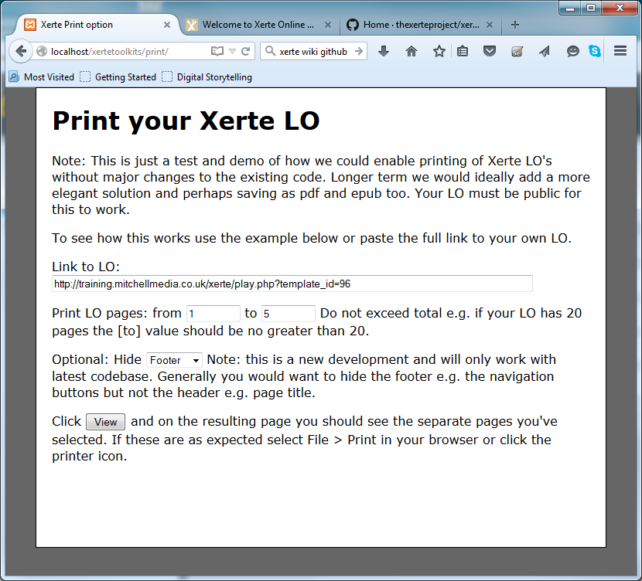

*Showing the print dialog.*

*Font Awesome Support*Font awesome is included in this release, allowing you to use a wide range of icons in your projects. Support for font awesome is provided via the new editor, or you can enter the HTML code directly. Font awesome provides over 1000 icons, and you can choose to display icons at a range of sizes.

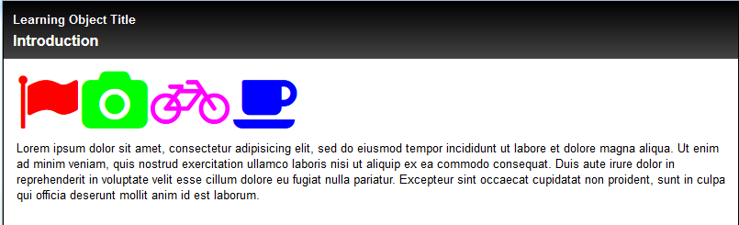

More information on font awesome can be found at the font awesome website: <http://fortawesome.github.io/Font-Awesome/examples/>

Bootstrap Template

*Export and import support*  
Import and Export are now enabled for Bootstrap projects.

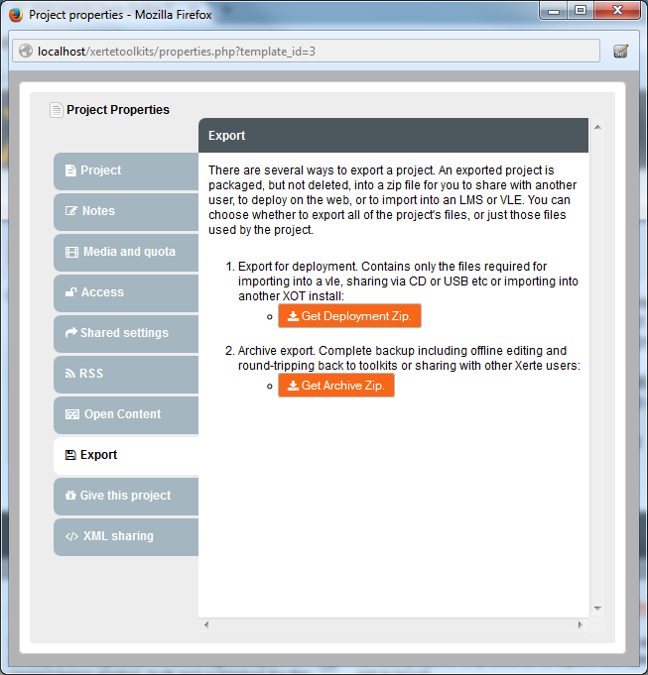

*Export and import are now enabled for the Bootstrap template.*

*PDF and PDF for Navigators*A new PDF item can be added to pages, and can also be added to navigator panes.

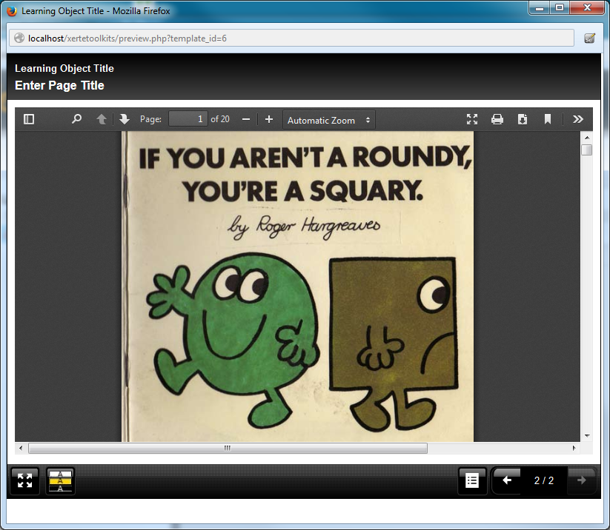

*Showing a PDF page in the HTML5 player.*

*Font Awesome Support*Font awesome support is also included in the bootstrap template. More information on font awesome can be found at the font awesome website: <http://fortawesome.github.io/Font-Awesome/examples/>

New Decision Tree Template

The new decision tree template allows you to create a decision tree for the user to follow. This is a path of branching content that can be used to walk the user through a number of decisions, perhaps to model real-world decision making processes. It could also be used to develop branching stories or other interactivity that can take the user through a number of steps.

